Willis Allstead

4/16/18

CS 219

HW8

4.1)

a) r3 stores the value that comes from adding r12 to r5

**- I’m trying to learn what happens when using the ADD instruction in assembly.**

b) r3 = r5 + r5

**- I’m trying to learn the value returned by a specific ADD instruction of r5 and r5.**

c) r3 = r3 + r3

**- I’m trying to learn the value returned by a specific ADD instruction of r3 and r3.**

4.2)

a) this results in the value of r2 being copied into r11, meaning r11 stores the value of what r2 was storing.

**- I’m trying to learn what happens when using the MOV instruction in assembly.**

b) now r4 contains the value of 28.

**- I’m trying to learn the effect of the MOV instruction in assembly with r4 and #28 supplied.**

c) r3 would not change since copying itself into itself will not cause a state change.

**- I’m trying to learn what happens when copying a register into itself.**

4.3)

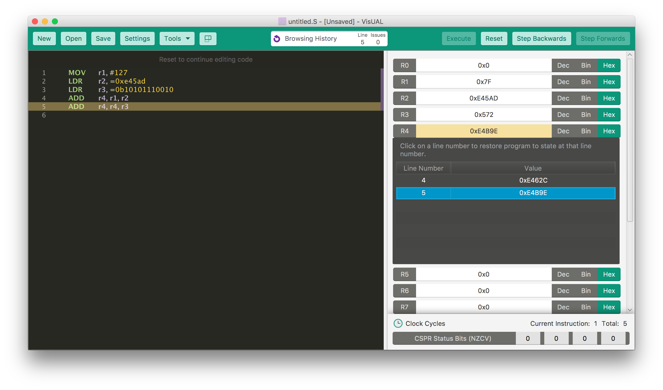I obtained the total of 0xE4B9E for the summation of these three numbers.

**- I’m trying to learn how to add numbers in ARM assembly, especially ones of different memory sizes.**

4.4)

a) After this instruction is executed the value in register r5 would be 0x0E74 since it would hold the value of the subtraction of decimal 209 from 0x0F45.

**- I’m trying to learn the effect of the SUB instruction in assembly with r5, r2 and #209 supplied.**

b) After this instruction is executed the value in register r5 would be 0x8C since it would hold the value of the subtraction of 0x045 from decimal 209.

**- I’m trying to learn the effect of the RSB instruction, similar to SUB but from the right number now.**

c) The problem that arises is that the value stored in r5 will be negative. This means it will need to be stored in two’s complement representation. R5 would equal 209 – 0x0F45 which equals decimal -3700 or 0xF18C.

**- I’m trying to learn the effect of the RSB instruction and how to represent the result in two’s complement representation.**

4.5)

a) the value in r8 would be the negative of 0xF4 which is 0x0B

**- I’m trying to learn the effect of the MVN instruction on a register with a numeric value.**

b) r3 would hold the summation of 0xFFFF and 0x045 which equals 0x0048 with an included overflow flag

**- I’m trying to learn the effect of the ADD instruction, in this case with numbers that would cause an overflow.**

c) r6 would be an incremented version of the previous value in r6. If r6 was 1, r6 would now be 2.

**- I’m trying to learn the effect of the ADD instruction, in this case in a similar use case of incrementing a number value.**